POTATO AND TOMATO LEAF DISEASE CLASSIFICATION USING DEEP LEARNING

First Author: Deep Raj Second Author Ashish Ranjan
¹ Princeton University, Princeton NJ 08544, USA
² Springer Heidelberg, Tiergartenstr. 17, 69121 Heidelberg, Germany
lncs@springer.com
Abstract. Farming is essential for food security and other industries. Potatoes and tomatoes are important crops in many countries, including India, and need to be protected. But these crops are prone to a range of diseases which affect their yield and quality. Farmers usually identify plant diseases by visually inspecting the leaves - a process that is time consuming and often inaccurate. Diseases are usually detected after symptoms have emerged, hindering timely measures. Our study introduces an automated system for plant disease detection using leaf images through deep learning. The researchers used a dataset of 30,274 images, which were preprocessed and split into training, validation and testing sets. The models CNN, VGG16 and VGG19 were used. The CNN model had an accuracy of 91.56%, while the accuracy of the VGG16 model was 97.40%. The highest accuracy of 99.06% was achieved with VGG19. The results indicate that deep learning techniques can be applied to detect plant diseases in agriculture.
Keywords: First Keyword, Second Keyword, Third Keyword.
- Introduction
Potatoes (Solanum tuberosum L.) and tomatoes (Solanum lycopersicum, L. 1753) are two of the world's most consumed crops that help feed the world. But two of the main diseases affecting both of these crops are early blight and late blight, which pose a problem to these crops and farmers. These diseases are caused by microorganisms, genetic abnormalities and pathogens (bacteria, fungi, viruses). Potato leaf diseases are caused by fungi and bacteria. Early detection of blight diseases on these infected potato and tomato plants can help farmers begin to take action. This will help farmers to minimise the damage and make the cultivation and harvesting easier. Current disease detection techniques: manual, Expert-dependent, time-consuming and inaccurate. Previously many computer vision and image processing researchers have suggested using traditional image processing methods such as LBP, K-means clustering for disease detection. With the help of Deep Learning (DL): Automatic disease detection is possible and High accuracy using leaf image analysis. While farmers employ various pesticides and insecticides to safeguard tomato plants, they may not be aware of the disease and its prevention. Overuse of insecticides and pesticides is harmful to human health and life. Misdiagnosis of diseases and over and under use of pesticides may damage the crop. It's important to diagnose diseases of tomato and potato plants. However, diagnosing these diseases by visually examining the plants is time-consuming and hard to do. So, a machine can be used to detect diseased tomato and potato plants, determine what type of disease they are infected with and use this knowledge to help the rest of the plants grow more effectively and with less wastage.
- Literature review
Today, automation of the disease detection process has evolved from a very specific issue into one of enormous significance for the whole agriculture sector. The traditional methods are now considered to be rather slow and inaccurate, whereas machine learning, particularly deep learning, has been increasingly applied to this issue. For instance, the article by Mohanty, Hughes and Salathé (2016) demonstrated that, by using CNNs trained on PlantVillage dataset, the highest accuracy of 99.35% was achieved. However, this was an in-lab experiment that was difficult to be reproduced in practice. In a further example, where Sladojevic et al. (2016) used images downloaded from the Internet, the accuracy was significantly lower because of a smaller number of images.
The next step in the evolution of methods for automated plant disease detection was experiments involving a variety of plants. For example, Ferentinos (2018) tested CNN models for 25 different plant species but claimed that the algorithms are not able to learn the information as the dataset was not diverse enough. Meanwhile, between 2017 and 2019, Brahimi et al. experimented with CNN models in the case of tomatoes and suggested a new method of visualisation, which enabled the algorithm to pinpoint the diseased part of the leaf. In addition, Too et al. (2019) concentrated on the accuracy of commonly used CNN models such as VGG16 and ResNet. They demonstrated that fine-tuned CNN models outperformed conventional image processing.
The most recent advances in the field include works by Yasin (2025) and Upadhyay (2025). The researchers began to develop fully automated solutions to the problem, which included all the steps, from data preparation to deployment in the field. Also, Krishna et al. (2025) have experimented with new network designs, such as EfficientNet and DenseNet, to further increase the efficiency of the system when dealing with real-world noisy data. Although the field has made considerable progress from the work of researchers like Singh, Hossain and Sharma, there is still a lot of room for improvement. Specifically, an automated, field-ready disease detection model has not been developed yet for potatoes and tomatoes.
- Methodology
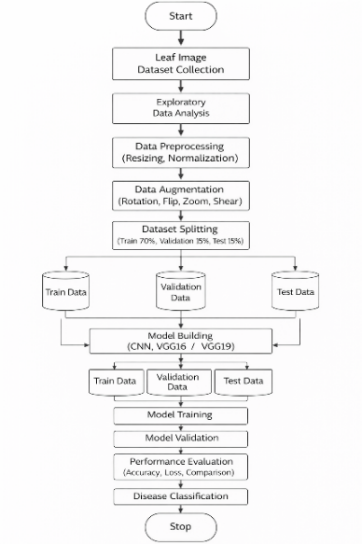
Figure 1: Methodology Flowchart

The proposed plant disease classification methodology involves a number of steps such as data collection, data preprocessing, data augmentation, dataset division, model training and evaluation. First, a dataset of potato and tomato leaf images was acquired. The images were preprocessed to reduce noise and resized to a uniform size. The dataset was augmented to increase the size and improve the model's performance. The data were divided into training, validation and test sets. Then, deep learning models (CNN, VGG16 and VGG19) were trained and tested. Finally, the performance of each model was evaluated to identify the best model for classification.
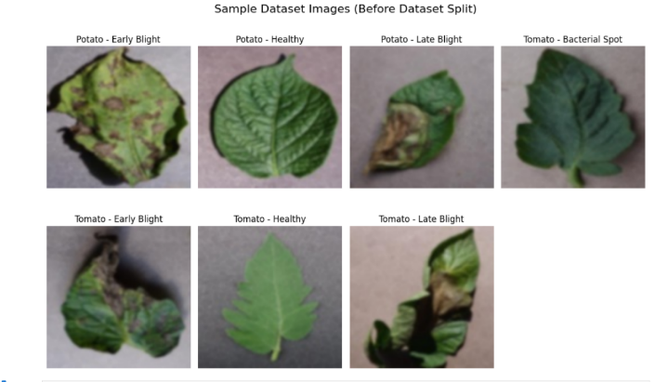
Figure 2: Sample Dataset Images (Before Split / Raw Images)

The dataset used in this research is the set of potato and tomato leaf images from a plant disease dataset. This dataset comprises of healthy and diseased images. The images of diseased leaves used in this study include Potato Early Blight, Potato Late Blight, Tomato Early Blight, Tomato Late Blight, Tomato Bacterial Spot and healthy leaf images of potato and tomato.
The dataset has 30,274 images in total with seven classes. The images were arranged in class-wise folders for accurate labeling and classification. Figure 2 shows some potato and tomato leaf images with various diseases.

Class | Label
Potato - Early Blight | 0
Potato - Healthy | 1
Potato - Late Blight | 2
Tomato - Bacterial Spot | 3
Tomato - Early Blight | 4
Tomato - Healthy | 5
Tomato - Late Blight | 6

  - Data Processing
Data preprocessing is an important step in deep learning to improve model performance. In this research, all images were resized to 128 × 128 pixels to maintain a uniform input size for the deep learning models. The images were normalized by scaling pixel values between 0 and 1. The dataset was then divided into training, validation, and testing sets using a 70:15:15 ratio. The training dataset was used to train the model, the validation dataset was used to tune model parameters, and the testing dataset was used to evaluate the final model performance.

  - Data Augmentation
Data augmentation techniques were applied to increase the number of training images and prevent overfitting. Various augmentation techniques such as rotation, flipping, zooming, and rescaling were applied to the training images. Data augmentation helps the model learn different variations of leaf images and improves the generalization ability of the model.

Augmentation techniques:
- Rotation
- Horizontal Flip
- Zoom
- Rescale
- Shear
The data augmentation was performed using the ImageDataGenerator function available in the TensorFlow Keras library.
  - Data Splitting
After data pre-processing and augmentation, the dataset was then partitioned into three sets namely; training set, validation set, and testing set. The data split took place in a 70:15:15 ratio where 70% of the images formed the training set, 15% of the images were for the validation set, while the other 15% comprised the testing set. The training set was employed for the training process of the deep learning models, the validation set was used for hyperparameter tuning and to avoid overfitting, and finally, the testing set was used for the model evaluation.

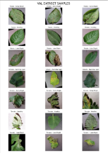
(a) training set
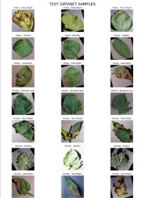
(b) validation set
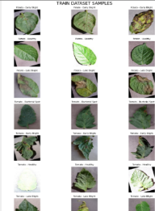
(c) testing set
Figure 3: Sample images from the dataset after splitting into (a), (b) validation set, and (c) testing set. Each row represents images from the same class.
  - Disease Classification using CNN, VGG16, VGG19
In the present work, three deep learning models are used to classify plant diseases, namely Convolutional Neural Network (CNN), VGG16 and VGG19. In the Convolutional Neural Network (CNN) model, there are several convolutional layers, pooling layers, flatten layer, and dense layers. The convolutional layers are used to extract features from the leaf images and the pooling layers reduce the size of the images. Finally, the dense layers are used for image classification using the Softmax function.
VGG16 and VGG19 are popular deep learning models that are used to classify images. They have a greater number of layers than CNN and, as a result, can learn more complex feature representations. The two deep learning models are trained using transfer learning.
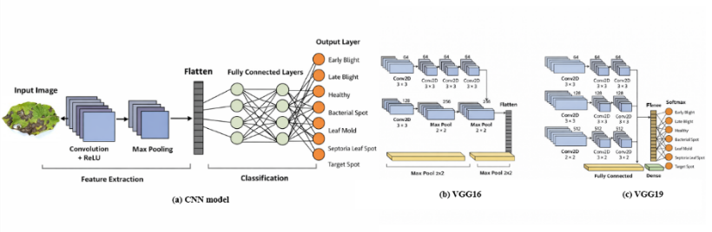
Figure 4: Architecture of (a) CNN model, (b) VGG16 model, and (c) VGG19 model used for plant disease classification.
Of the three, the architecture of the VGG19 model is deeper than that of the CNN and VGG16 models, enabling it to detect more intricate patterns within the images, hence improved classification performance. Of the three, the architecture of the VGG19 model is deeper than that of the CNN and VGG16 models, enabling it to detect more intricate patterns within the images, hence improved classification performance.

Layer | Filters | Kernel | Activation
Conv2D | 16 | 3×3 | ReLU
MaxPool | - | 2×2 | -
Conv2D | 32 | 3×3 | ReLU
MaxPool | - | 2×2 | -
Conv2D | 64 | 3×3 | ReLU
MaxPool | - | 2×2 | -
Dense | 128 | - | ReLU
Dropout | 0.5 | - | -
Dense | 7 | - | Softmax

Table 1: Depiction of layers and parameters involved during training of the CNN model.
- RESULTS AND DISCUSSION
  - Training Process
The three models were trained on the training dataset and validated on the validation dataset. The accuracy and loss were tracked throughout training. As training progressed, the training accuracy improved and the loss dropped, indicating that the model was successfully learning from the data. The validation accuracy curve also showed a similar pattern, which indicates that the model was not overfit. The training and validation curves for CNN, VGG16 and VGG19 models are shown in Figure 5.

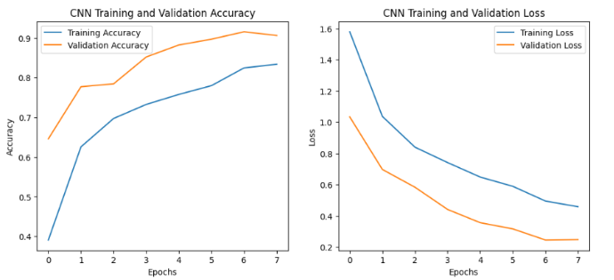
Figure 5 (a) CNN Graph
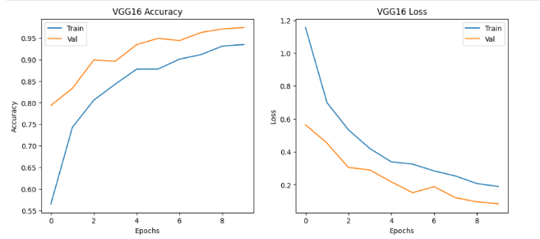
Figure 5 (b) VGG16 Graph
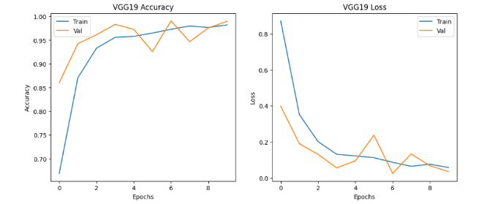
Figure 5 (c) VGG19 Graph
Figure 5: Training and validation accuracy and loss curves for (a) CNN, (b) VGG16, and (c) VGG19 models.

  - Testing Process and Model Comparison
The models were tested on the test set to assess their performance. The CNN model's accuracy was 91.56%, the VGG16 model's accuracy was 97.40%, and the VGG19 model's accuracy was the highest at 99.06%. The models' accuracy is compared in Figure 6. It can be seen from the results that the VGG19 model outperformed CNN and VGG16 because it is a deeper network that has the ability to extract more features. It is evident from the graph that the VGG19 model has better accuracy than CNN and VGG16. This is because VGG19 network is deeper and able to learn more details from the images of plant leaf. So, VGG19 is the best model to detect plant diseases in this study.

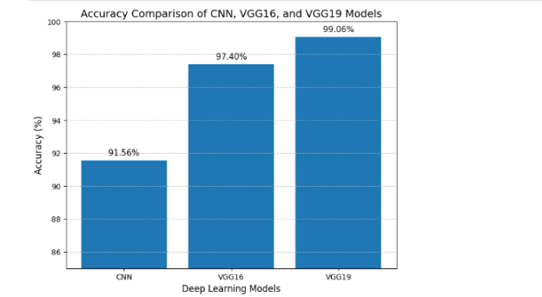
Figure 6: Accuracy comparison of CNN, VGG16, and VGG19 models. The VGG19 model achieved the highest accuracy of 99.06%, followed by VGG16 with 97.40%, while CNN achieved 91.56%.

CONCLUSION AND FUTURE WORK
classify plant diseases from leaf images. The data was preprocessed and augmented for better results. Three deep learning models, CNN, VGG16 and VGG19 were compared. The VGG19 model had the best accuracy of 99.06%, and was the best model for plant disease classification.
This model can be used in the future to develop mobile and web apps for detecting plant diseases. The accuracy of the model can be further improved using more plant diseases and data. Other deep learning models like ResNet and EfficientNet can also be explored to improve the performance.

REFERENCES
1. L. Meno, O. Escuredo, M. S. Rodriguez-Flores, and M. C. Seijo, “Looking for a sustainable potato crop: Field assessment of early blight management,” Agricultural and Forest Meteorology, vol. 308, p. 108617, 2021.

2. R. Kundu, D. Dutta, M. K. Nanda, and A. Chakrabarty, “Near real-time monitoring of potato late blight disease severity using field-based hyperspectral observation,” 2020.

3. J. Rotem, The Genus Alternaria: Biology, Epidemiology, and Pathogenicity. American Phytopathological Society, 1994.
4. M. Saha and Sasikala, “Identification of plants leaf diseases using machine learning algorithms,” International Journal of Advanced Science and Technology, vol. 29, no. 9s, pp. 2900–2910, 2020.
5 H. Durmuş, “Disease detection on leaves of the tomato plants by using deep learning techniques,” in International Conference on Agro-Geoinformatics, 2017, pp. 1–5.
6 V. K. Vishnoi, K. Kumar, and B. Kumar, “Plant disease detection using computational intelligence and image processing,” Journal of Plant Diseases and Protection, pp. 19–53, 2021, Springer.
7 Q. Liang, Y. Xiang, Y. Hu, and G. Coppola, “Computer-assisted plant disease diagnosis and severity estimation network,” Computers and Electronics in Agriculture, vol. 157, pp. 518–529, 2019.
8 A. Badage, “Crop disease detection using machine learning: Indian agriculture,” International Research Journal of Engineering and Technology (IRJET), vol. 5, no. 9, 2018.

9 A. Iqbal and K. H. Talukder, “Detection of potato disease using image segmentation and machine learning,” in International Conference on Wireless Communications Processing & Networking, 2020, pp. 43–47.
10 T. Prajwala, “Tomato leaf disease detection using convolutional neural networks,” in International Conference on Contemporary Computing (IC3), 2018, pp. 1–5

